 | VC[Series Code]SH[Unique index per investor/ investment]  (Certificate No) | [Number of Certificates] Units  (No of Certificates)  (subscription pack) | December 16, 2025 [Closing date]  (Date)

(logo of the vehicle)

EQUITY CERTIFICATE

& STATEMENT OF HOLDINGS

VERSO Capital 2 SCSP [Vehicle Name], the Issuer, in the name and on behalf of Series [Series Code] 209 “X.AI”
Company Number: [Vehicle Registration Number] B291900

This is to certify that [FIRST NAME LAST NAME or ENTITY NAME] PREAMBLE X CAPITAL I, A SERIES OF PREAMBLE X CAPITAL LLC the registered holder of [Number of Certificates] 40,106 Certificates only as issued by the Issuer and ultimately backed by [Subscription | Underlying Units] 40,106 [Subscription | Product description] Shares of Series B Preferred Stock of X.AI.

This certificate was authorised by:

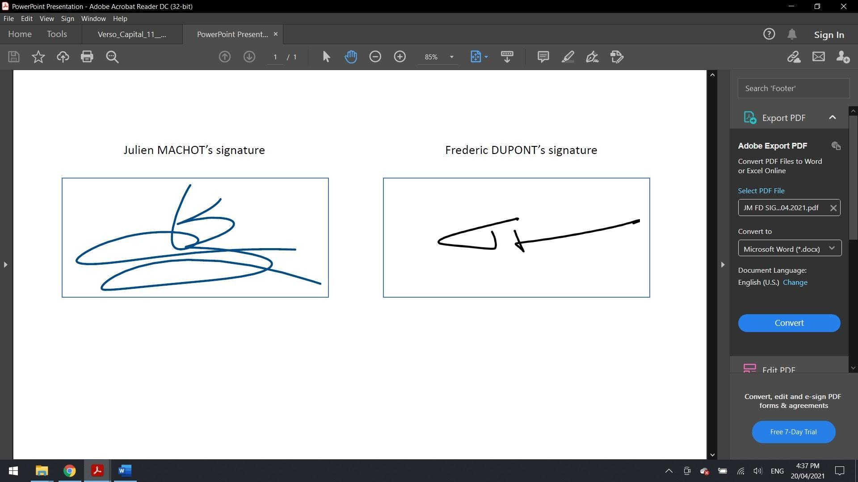 | VERSO Capital 2 SCSP [Vehicle Name]  2 Avenue Charles de Gaulle  L-1653 Luxembourg [Vehicle Address]  acting in the name and on behalf of its  Series [Series Code] 209
Mr Julien Machot  Managing Partner |  | Mr Frederic Dupont  General Counsel

